**Pipeline Using Blue Ocean**

**~By Krishan Rupani**

**Blue Ocean: Blue Ocean rethinks the user experience of Jenkins. Designed from the**​  **ground up for** [**Jenkins Pipelin**](https://www.jenkins.io/doc/book/pipeline/)​ [**e,**](https://www.jenkins.io/doc/book/pipeline/)​ **but still compatible with freestyle jobs, Blue Ocean reduces clutter and increases clarity for every member of the team.**

**Features:**

* **Sophisticated visualizations of continuous delivery (CD) Pipelines**
* **Pipeline editor**
* **Personalization**
* **Pinpoint precision**
* **Native integration for branch and pull requests**

**1. Make sure your Jenkins is up and running.**

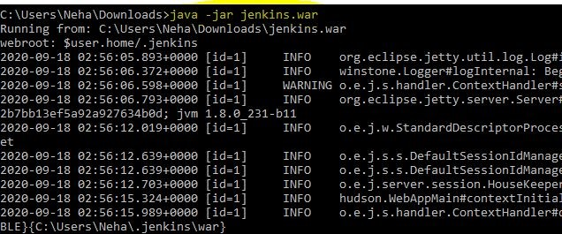

**2.**

**Move to left side, Manage Plugins**

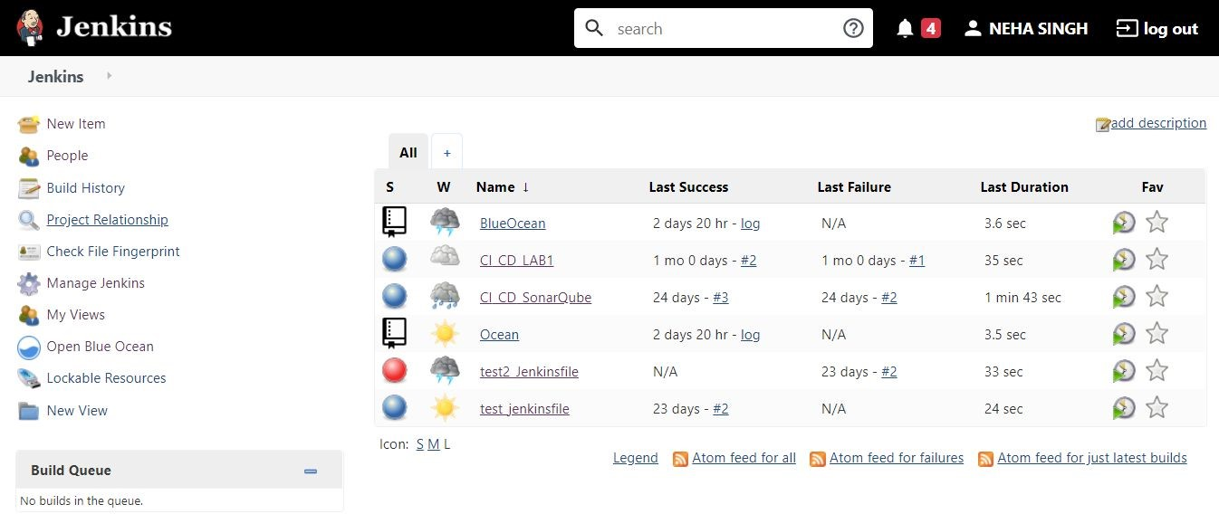

**3. Click on Manage Plugins**

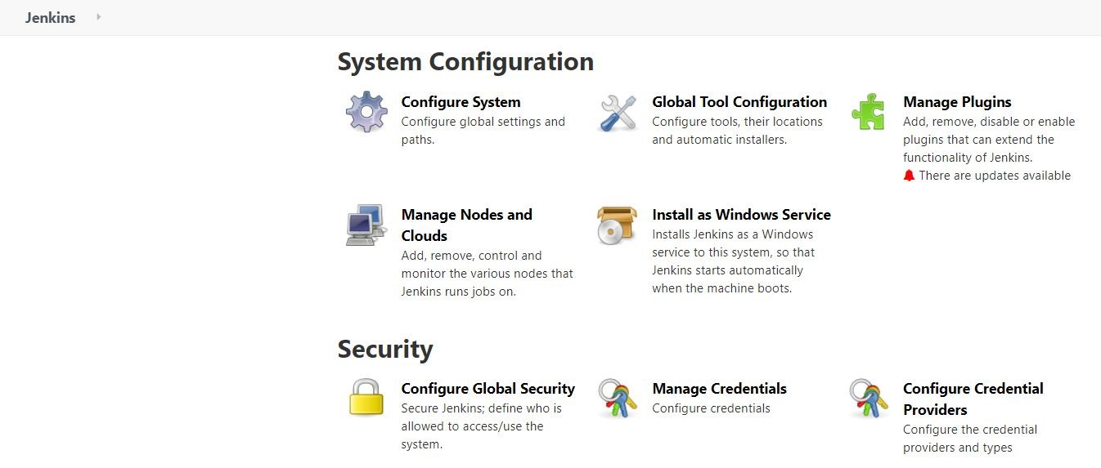

**4.**

**Install a plugin in Jenkins for Blue Ocean**

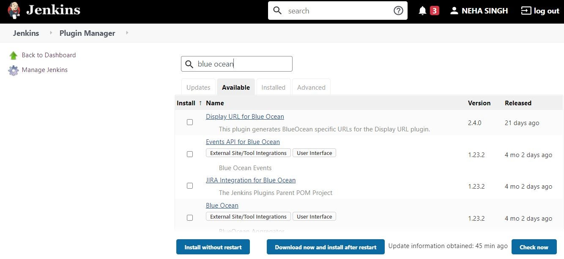

**Make new GitHub Repository for maven project with pom.xml in the main folder**

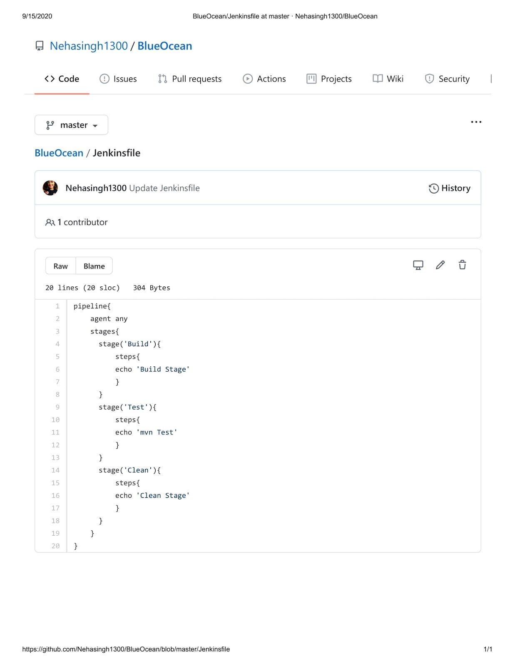

**Upload Jenkinsfile**

**p**

**i p e l i n e**

**{**

**agent any stages{**

**stage('Build'**​ **){**​  **steps{ echo**

# 'Build Stage'

**}**

**}**

**stage('Test'**​ **){**​  **steps{ echo 'mvn**​

**Test'**

**}**

**}**

**stage('Clean'**​ **){**​  **steps{**

**echo**

# 'Clean Stage'

**}**

**}**

**}**

**}**

**Create Blue Ocean Pipeline with GitHub.**

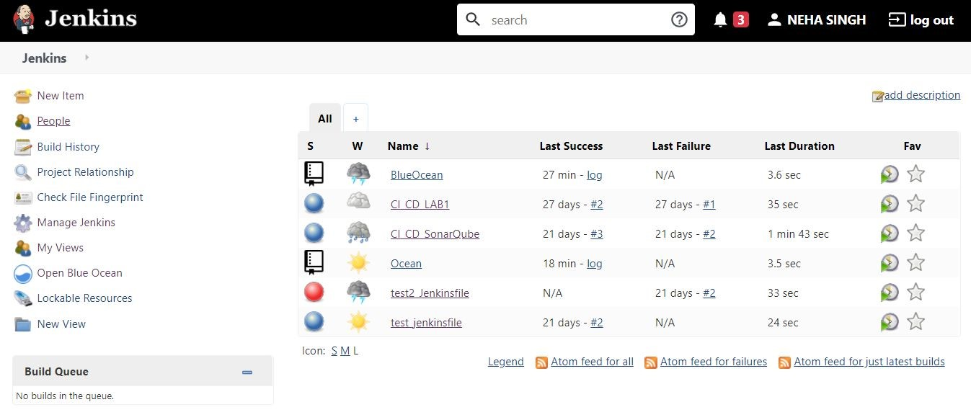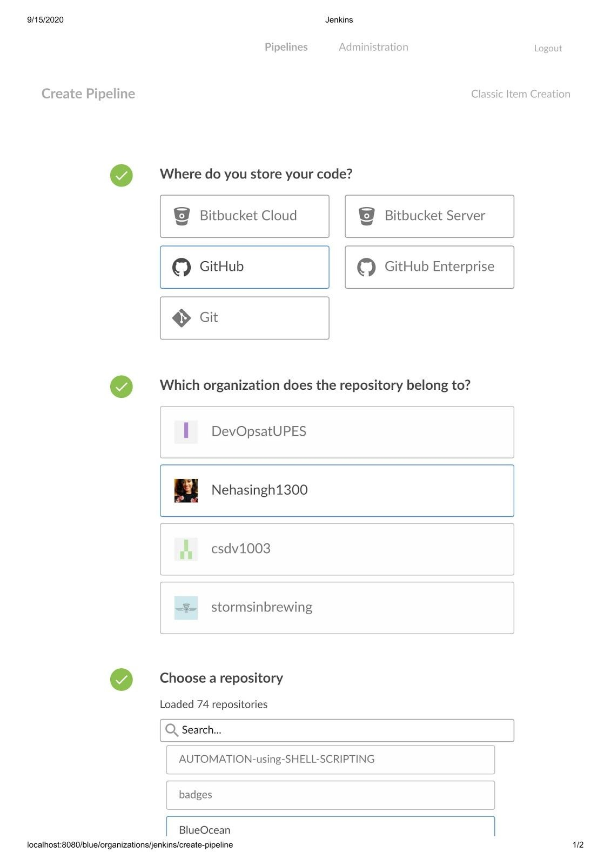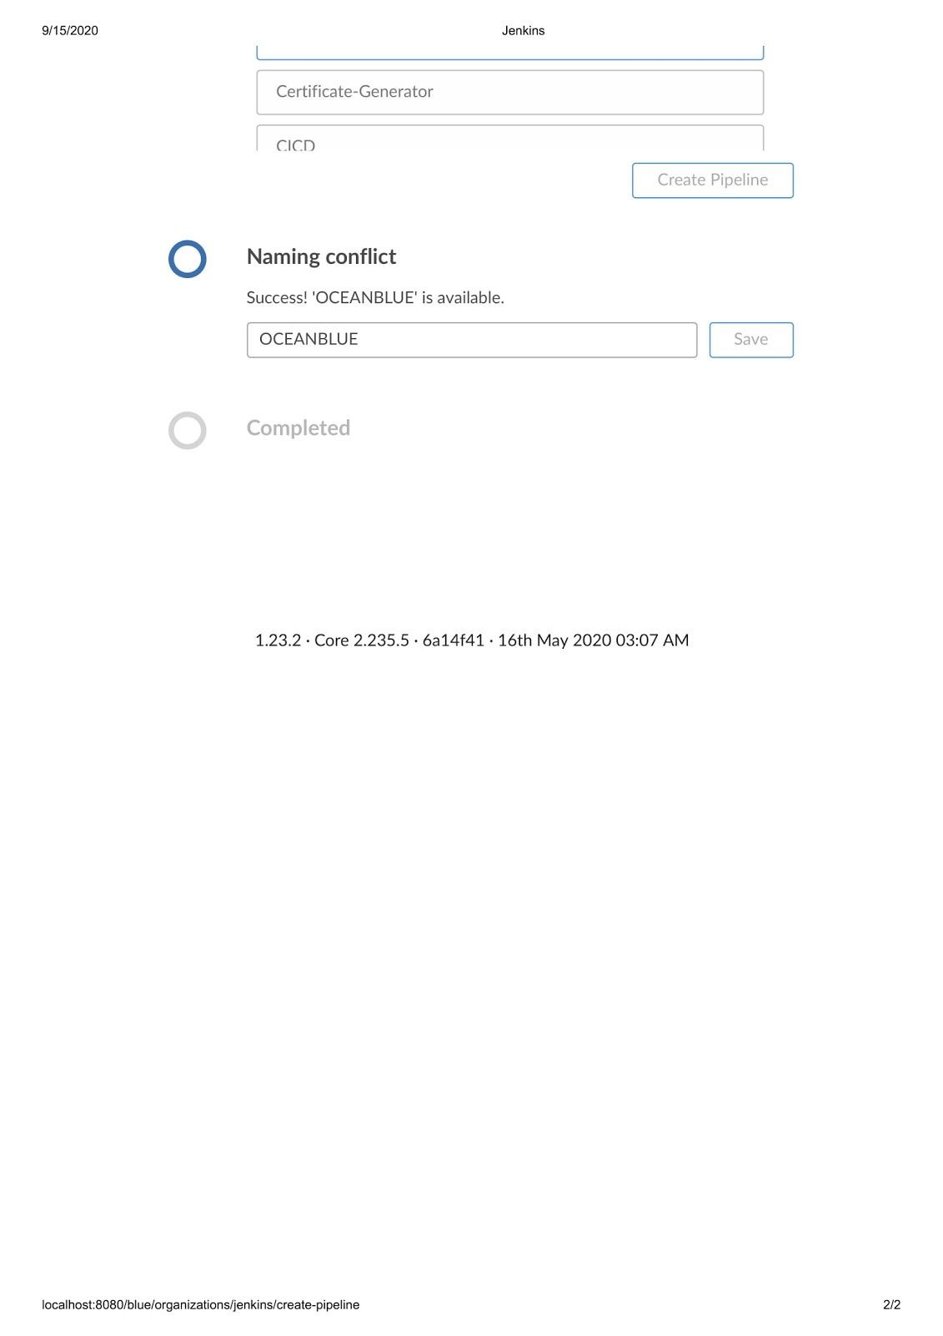

**8. Now, you can see a screen where all your stages are successfully implemented.**

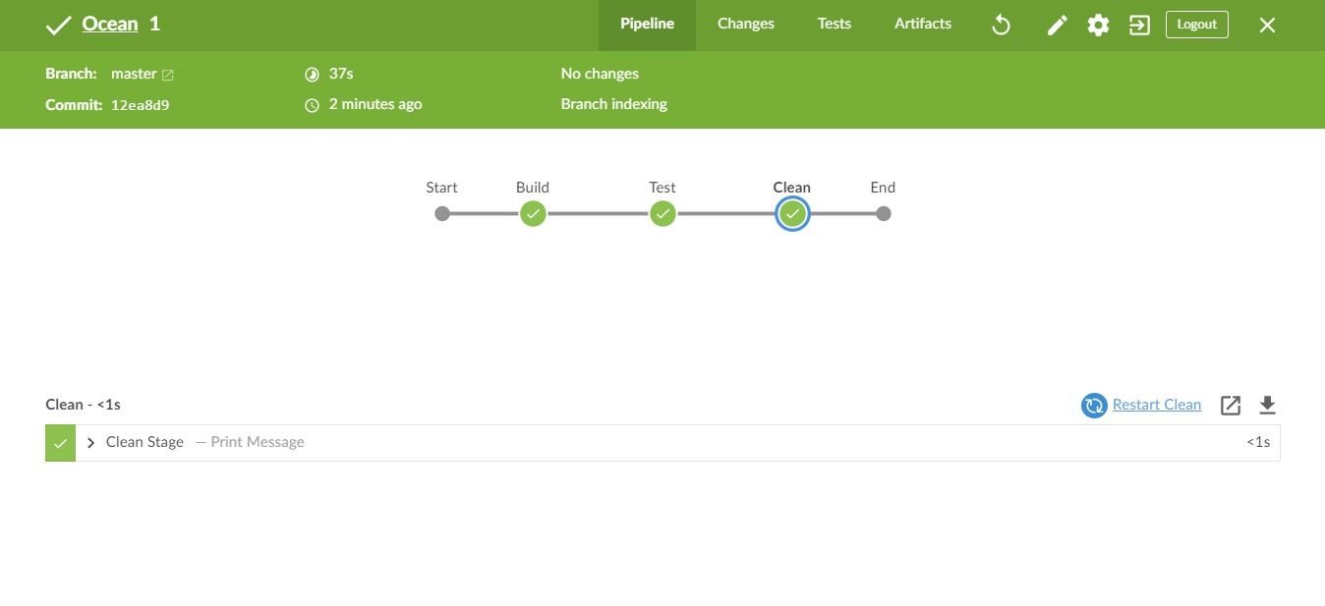

**You can also check my video on** [**YouTube for the same BlueOcean Tuitorial**](https://www.youtube.com/watch?v=JjQ3HgwnPkI&t=64s)​ [**.**](https://www.youtube.com/watch?v=JjQ3HgwnPkI&t=64s)

**That’s all for this session.**